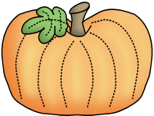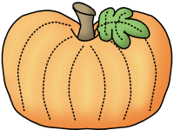

Thank you to all of the chaperones who joined us for our trip to Aunt Louise’s Farm! We had an awesome time and I have you to thank for your assistance!



**Savvas Reading-** **Unit 1 Week 5**

***Theme: How can we describe special places?***

***Text: What Is in a Neighborhood?***

***Letter Recognition & Sounds:***

Bb and Rr

***Sight Words:***

for, me, with, an, ran

***Vocabulary:***

tools, pencils, markers, brushes

***Genre:*** Informational Text

***Language and Conventions:***

Singular and Plural Nouns

**Math- *Chapter 3:***

***Count and Represent Numbers Through 9***

The Chapter 4 Test will be **Monday, October the 23rd**. I do not need the homework packet returned.

**Science-**

Autumn

**Monday, 10/16**

**Teacher Planning Day (No School)**

**Wednesday, 10/18** Picture Retakes

**10/20** Pink Out! Wear your pink to school!

**10/23-11/3**

Boosterthon Fun Run Collections

**Wednesday, 10/25**

50th Day of School (Dress in 50’s wear!)

**Tuesday, 10/31**

Fall Party and Favorite Book Character Dress Up Day

**Friday, 11/3** Fun Run!

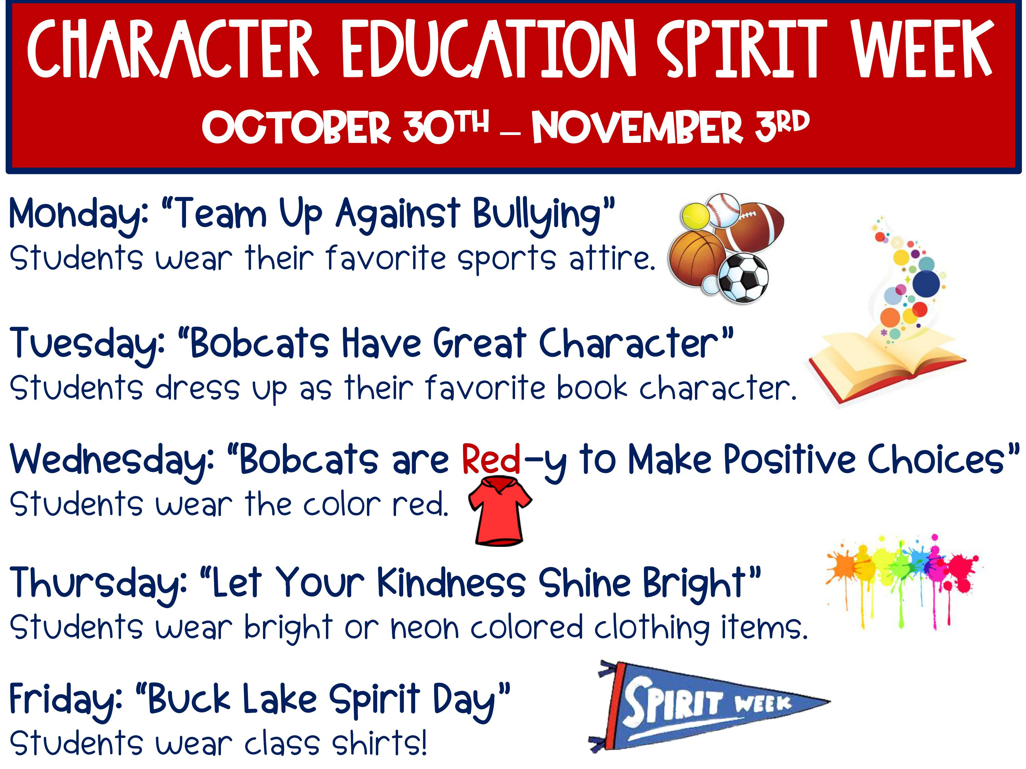

**Sonja Darden’s Kindergarten Class**

**Buck Lake Elementary** 488-6133 [dardens@leonschools.net](mailto:dardens@leonschools.net)

**October 16, 2023**

